École St. Angela Merici
Catholic Community School Council Meeting
Tuesday January 13, 2026 at 6:30pm
Richard Turchenek Resource Centre and MS Teams Online

ATTENDANCE: Vinni Vongkhamchanh, Amanda Garrioch, Daniela Glover, Fawn Sullivan, Yolande Howrie, Tricia Shynkaruk, Anna von Staden
Online: Krista Horwath, Michael Oroz, Ronda Nye

Welcome & Prayer: Led by Daniela Glover

Read and Review Agenda: Led by Daniela Glover

Motion to Approve Agenda: Fawn Sullivan
Seconded: Yolande Howrie
Motion passed.

Motion to Approve November 4, 2025 Minutes: Fawn Sullivan
Seconded: Yolande Howrie
Motion passed.

Chair’s Report and Correspondence – Led by Daniella Glover

Mom’s pantry fundraiser is now completed. There were some challenges at the end of the fundraiser but overall it was a successful fundraiser. Commission earned totaled $872.18 and a $60 credit for future use was provided for the mix ups. Cheques will be deposited after this meeting and included in the next financial report.
Treasurer’s Report – Led by Amanda Garrioch
Account balances:
- Operating $15,576.39
- Playground $59,586.63
- Redeemable GIC’s (for playground) $71,000
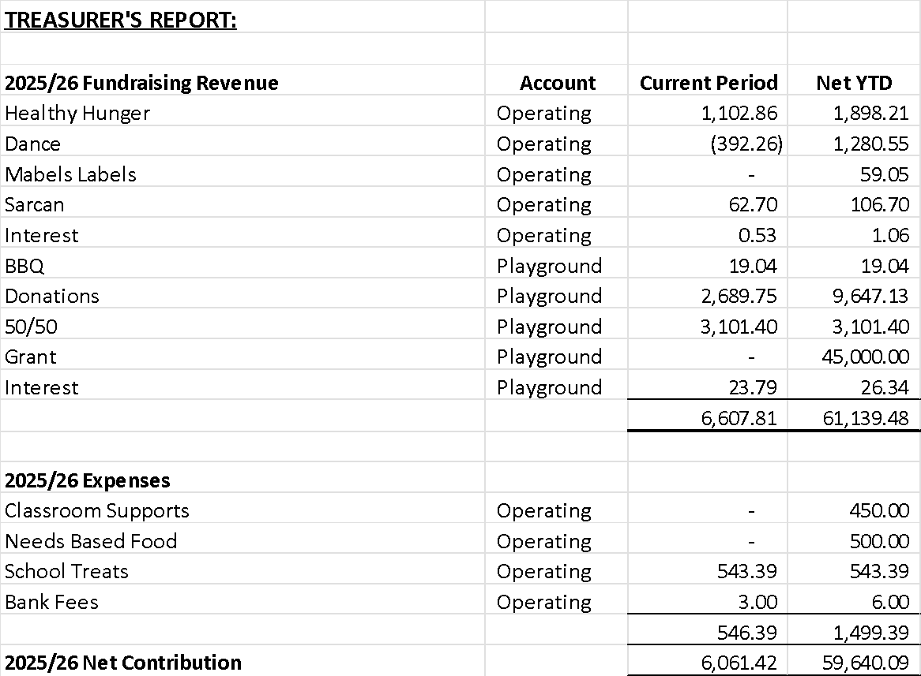

Motion to Accept Treasurers Report: Fawn Sullivan
Seconded: Vinni Vongkhamchanh
Motion passed.

Administration’s Report – Led by Tricia Shynkurk

Discussion points:

- School photos:
  - Administration asked the CSCC is they were happy with the current school photographer
  - Most of the CSCC responded that they are happy with the quality of the current photographer but are open to exploring other options. Tricia will collect and pass along offers for the CSCC to decide on by the March 2026 meeting.
- School Start:
  - The school earns a commission and the parents benefit from the convenience of using this school supply order platform. Agreed to continue next year.
- Kindergarten Registration:
  - Discussion was held on how we can advertise and spread the word on kindergarten registration, including:
    - Post in community association newsletters/websites, post posters in high visibility public areas such as Regina Public Library, Co-op, YMCA etc
    - Social posts via RCSD, St. Angela CSCC etc
    - Better link on RCSD’s website
    - Make an Instagram reel to highlight the benefits of French Immersion
  - Will seek CSCC and teacher feedback on content prepared for advertising

Old Business - None

New Business
- Playground Committee Update
  - The Playground Committee met with admin and teaching staff to review playground plans and receive feedback on the design and placement. Thank you to the playground committee for their time and communication and thank you to the teachers for their valued input.
  - City of Regina has supplementary requirements including benches, pathways etc that will make the project cost prohibitive
    - Exploring how we proceed forward. May not be able to meet requirements and may have to return grant funding.
    - Rubber paving required ($40K cost). Working on a grant to cover the majority of this cost.
    - 50% of playground components have to be accessible
    - Extensive debate was held over how to proceed and whether we return the grant funding or try to meet the requirements
    - Need to start project by May 2026 but need to submit architectural plans for approval first
  - Saskatchewan Government grant funding also has a one year timeline (Oct 2026)
- Teacher Appreciation
  - Feb 9-13th week
  - Food is appreciated – a list of dietary restrictions will be obtained from admin
  - Pop is popular
- Valentines treats for kids
  - Thoughts?
- Cashable GIC
  - Discussion was held and agreed to invest $57,000 into a 1 year redeemable GIC at 2.55% with Conexus.
- Roundtable:
  - Mom’s Pantry Fundraiser
    - There were a couple of mistakes in the orders but a discount cheque was provided to compensate for the error.

Motion to Adjourn Meeting at 8:06pm: Vinni Vongkhamchanh
Motion passed

Our next meeting is February 2nd @ 6:30 pm

