Library helpers & Schedules

Monday and Friday:  3 Blind mice:  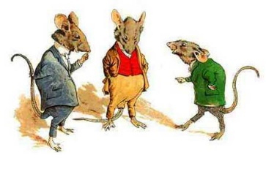  Thianna  Claire  Morgan | Tuesday:  Shelving Sisters  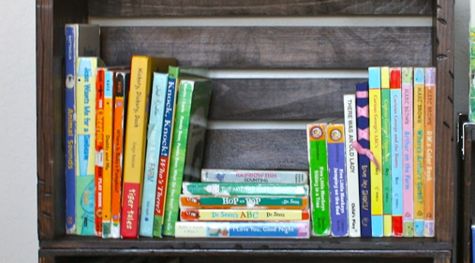  Elizabeth R  Josette  Camryn  Aminah | Wednesday:  Lightening Thieves    Lily  Emily  Chaydin  Elizabeth K | Thursday:  Tinmen  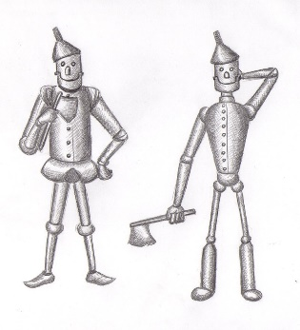  Vienna  Gabby  Ella  Sophia

Duties include:
- Shelving fiction and non-fiction books from buckets
- Ensure theme buckets and baskets are in order and have the correct books
- Tidying displays and shelves (straightening books, dusting, Lysol)
- Lysol wipes on tables, chairs and shelves
- Help choose new non-fiction for theme buckets (K-3 area)
Grade 7 bulletin board “crew”

L`équipe | Le mois | Le thème
Kianna & Aly | Octobre | L’haloween
Jelly beans | Novembre | automne
Georgia & Silas | Decembre | Noel
Kianna & Aly | Janvier | Nouvel an
Jelly beans | Fevrier | St valentin
Chaydin, Lizzy K | Mars | St Patrice
Spice Girls (Claire, Liz, Morgan, Aminah, Thianna, Josette & Camryn) | avril | Paques
Danica & Gracie | Mai | Le printemps
Spice Girls | juin | L’été

