École St. Angela Merici
Catholic Community School Council Meeting
Thursday, September 14, 2023
Richard Turchenek Resource Centre and MS Teams Online

Welcome: Led by Merelda

Read and Review Agenda: Led by Merelda

Motion to Approve Agenda: Daniela
Seconded: Krista
Motion passed.

Chair’s Report and Correspondence – Led by Merelda
Welcome to the new school year!
The CSCC Executive team is excited to see all the great things to come in 2023-2024

Treasurer’s Report – Led by Krista
Playground Account: Approximately $530.00 made from Back to School Bag Drop off BBQ – Balance: 17,127.94
*$1000 Ministry of Education 2023-2024 Grant to be put towards BBQ expenses

General Account: 2 Cheques: 388.00 – Donation from Regina Catholic School and $346.44 from SLGA – Balance: $9,403.25

Motion to Accept Treasurers Report: Kenny
Seconded: Andrea
Motion passed.

Administration’s Report – Led by Daniel L.

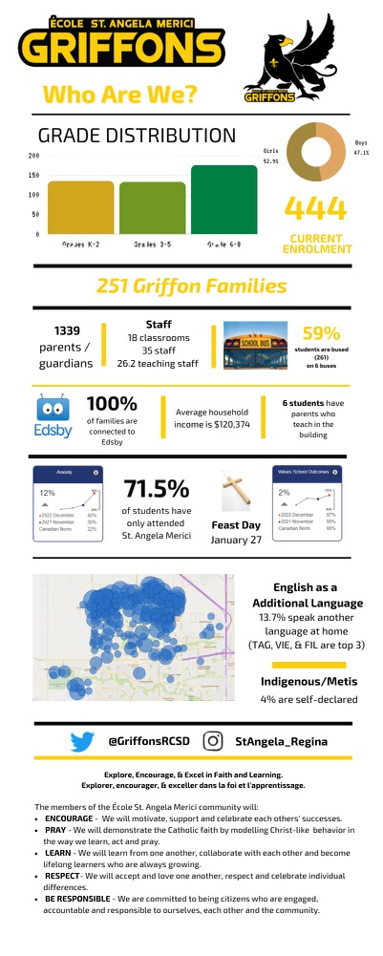
Angel Fund Committee: Led by Merelda P.
- Nothing to report this month

Old Business

1) Playground Committee Update – Led by Andrea and Kenny
- Back to school BBQ was a success with lots of compliments from the community
-Playground committee will meet October 24th, 2023, to discuss the year ahead
-Posters have been printed and placed around the rotunda with QR Codes and progress thermometer
-Backpack drop off BBQ was organized and went well
-A student parent has reached out to the committee about assisting with construction services as well as large sponsorship opportunities
-More awareness is needed that the funds raised throughout the year help the entire school playground with the focus being the K-1 playground

2) Fundraising Schedule – Led by Merelda
- Throughout year – Hot Lunch Program (funds going Operating Account)
- Sarcan Bottle Drive – September (funds to Playground Account)
- FarmFresh Vegetable Order – Thanksgiving (Oct 3/4)
- Fundscrip GiftCard Order – November 15-29
- Online Auction - Spring 2024

New Business
1) Classroom Supports/Enhancements – Led by: Merelda

Motion to provide $150 per teacher (with the option of more throughout the year dependent on fundraising), calculated appropriately by FTE to a maximum of $150.00/staff member: Rhonda
Seconded: Natasha
Motion Passed

2) Healthy Hunger Hot Lunch Program – Led by Jenna
- Will start up again at the end of September, parents to receive communication and instructions shortly
- To be handled in the same manner as the last school year

Motion for Funds from Hot Lunch to go to General Operating Account- Daniela
Seconded – Natasha J.
Motion Passed

3) Halloween Dance – Led by Merelda
- October 27th tentative date
- Signup Genius will be used for volunteer sign up
- Breigh will book DJ once date is confirmed with Administration

4) Set This Year’s CSCC Meeting Dates for 2023 – Led by Merelda
- Wednesday, October 11,2023 @ 6:30pm
- Monday, November 20,2023 @ 6:30pm
- No meeting in December

Motion to Adjourn Meeting: Krista
Seconded: Breigh
Motion passed.

Our next meeting is: Wednesday, October 11,2023 at 6:30pm. We can’t wait to see you there!

