École St. Angela Merici
Catholic Community School Council Meeting
Monday September 16, 2024
Richard Turchenek Resource Centre and MS Teams Online

ATTENDANCE: Jennifer Stewart-Mitchell, Vanessa Wiseman, Rachel Courchene, Derek Fischer, Petra Riffel, Daniela Glover, Rhonda Nye, Amanda Garrioch, Jenna Peters, Mike Orosz

ONLINE: Merelda Potter

Welcome: Led by Daniela
Prayer: Led by Jennifer

Read and Review Agenda: Led by Daniela

Motion to Approve Agenda: Daniela
Seconded: Amanda
Motion passed.

Motion to Approve Past Meeting Minutes: Daniela
Seconded: Rhonda
Motion passed.

Chair’s Report and Correspondence – Led by Merelda
- Schedule for this year has been discussed and will be shared once restaurants confirm
- Accounts being transferred to the new executive
- Calendar will be made by Fawn Sullivan to distribute
- Jenna Peters will continue to run hot lunches
- Bree McDavid will run the Halloween dance
- Andrea Birchard will continue to run the auction this year, does need help, will put out a call earlier for items for the auction

Angel Fund Committee - Led by Merelda
- Nothing at this point in time

Treasurer’s Report – Led by Amanda
Bank Account Balances as of Sept 16, 2024:
Playground $19,509.86
General/Operating - $11,054.56

- Forms are being printed and taken to the bank to transfer accounts to the new executive
- No formal report available

Motion to Accept Treasurers Report: Daniela
Seconded: Jenna
Motion passed.

Administration’s Report – Led by Jennifer
Sept 2024 Principal Report
- Current 410 students
- 17 Classrooms / 20 Teachers / 1.4 IA Staff
- 5 Connected Educator Classrooms (1:1 Devices)
- At the end of September all students who are registered are used to calculate our Funding per student from the government
- Household income stats come from the Behringer Report from the Administration
- Our School Data information did not get fully complete last year – more info can be shared at the next CSCC meeting


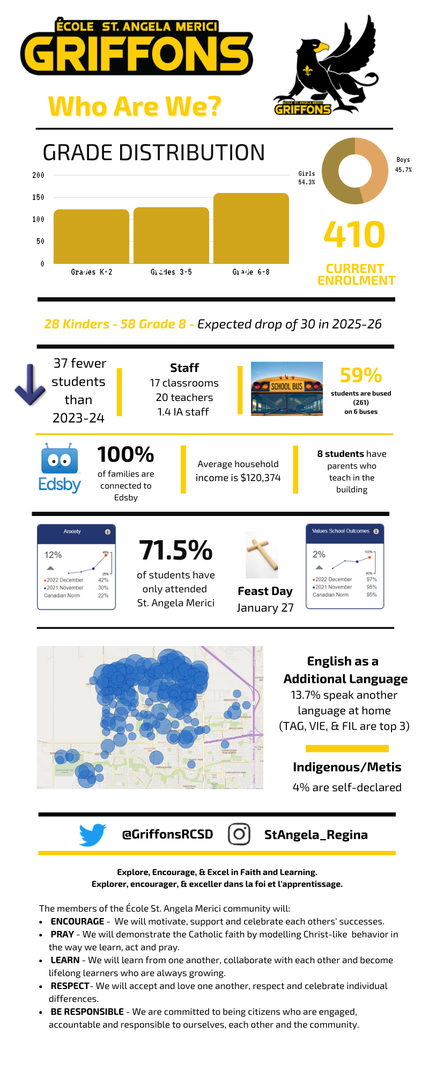

Old Business
- Year End Gifts
  - On Jun 12, 2024 the CSCC Executive approved the purchase of 3 - $50 Gift cards to Dutch Growers as thank you gifts to the past Executive.
  - On Jun 23, 2024 the CSCC Executive approved the purchase of 4 - $25 Gift cards to Tim Hortons as thank you gifts to leaving teachers.

New Business
- Hot Lunch Program for 2024-2025
  - Dates are approved by Admin & Chair
  - One a month approximately
  - Teacher emails will include a message reinforcing that the Hot Lunches raise money for the CSCC
  - 10% approximately will come back from Hot Lunches
  - Prices have increased in order to increase profits now that the money comes to CSCC instead of going to the office/school
  - Jenna will look again if there is an option for monetary donations *Not an option
Motion for money to Healthy Hunger proceeds to go to General Account: Fawn
Seconder: Amanda
Motion passed

- Change Bottle Fundraiser Dates & Prizes
  - Executive will purchase water bottles for all students to bring in the change
  - Executive will roll the money, Teachers will write names on water bottles
  - Is there an online donation option? Jennifer and Fawn will figure out if possible. * Not an option
  - Add more individual prizes for early bird? Add more prizes for individual winners in the end.
  - Class prizes – Slushies / Popcorn / Candy Salad / Sundae
  - Goal $ amount will do VP/P
  - Dates *Oct 9-23
  - Is there an option to visualize the amount raised for each class? Thermometer *Mme Wiseman’s class will make them
  - Thermometer for School $ raised with goals for each amount with teacher incentives *Mme Wiseman’s class will make
  - Jenna Peters will talk to staff for incentives and let us know
Motion for money from Change Bottle Fundraiser to go to General Account: Daniela
Second: Amanda
Motion Passed

- Playground Committee Update (orosz.michael@gmail.com)
  - No one on committee right now – Mike/Brian thinking about chairing the committee
  - If someone wants to take over applying for grants then the info will be passed on
  - Extra Money from other fundraiser get rolled into the Playground account when CSCC expenses are covered
  - Making contact with Board of Trustees regarding the policies and procedures surrounding the playground. We need RCSD to commit to the cost of removing the current structure as it is the large part of the hold up. *RCSD will not remove the current structure the cost would be on the CSCC. The policy regarding the playground (additions must be add by the same company that built the original structure) is a safety policy made by those that govern the safety of playgrounds not the RCSD.
  - Mike’s companies can support the installation and other labour costs. Mike’s crew can do Demo work as well.
- Halloween Dance Planning
  - Mme Wiseman’s class will take on the setup. Will give them a $200 cheque to buy supplies.
  - Proposed Date: Oct 25th
  - Will use the sign up sheet from last year again this year for volunteers.
  - 50/50 Raffle will go ahead. Fawn will apply for the license.
  - What supplies need to be topped of for the canteen – check the popcorn / pop
  - We will need receipts for dance expenses to be accountable for the RCSD Grant
- Allocate Funds to Accounts
Motion FundScrip to playground & Auction to playground - Amanda
Second: Daniela
Motion Passed

Motion RCSD grant money to go toward the dance - Daniela
Second: Amanda
Motion Passed

- Social Media Blast
  - Sarcan
  - QR Code Playgound
  - Create an Instagram account
  - Fundscrip (Nov 8th to 22nd)
  - Posting Regularly
    - Teacher fun facts
    - Increase engagement
- Director Changes from RCSD
  - Andrea Birchard is Director of Spring Auction
  - Rhonda Nye is Director of Mabels Labels / Playground / Newsletter
  - Hayley Fischer is Director of Social Media
- Schedule Next CSCC Meeting Dates (min 7 meetings per year)
  - October 7th @ 6:30pm

Motion to Adjourn Meeting: Rhonda
Seconded: Fawn
Motion passed

Our next meeting is October 7th @ 6:30pm Hope to see you there.

