École St. Angela Merici
Catholic Community School Council Meeting
Monday, April 22,2024
Richard Turchenek Resource Centre and MS Teams Online

Welcome: Led by Merelda

Read and Review Agenda: Led by Merelda

Motion to Approve Agenda:Krista
Seconded: Daniela
Motion passed.

Motion to Approve Past Meeting Minutes: Daniela
Seconded: Krista
Motion passed.

Chair’s Report and Correspondence – Led by Merelda
- Continuing to keep Facebook up to date with school news and upcoming events
- Wednesday, April 24,2024 – Teacher Appreciation Lunch from Bone and Broth
- Correspondence has gone out about parent support and volunteers needed for the CSCC next year
- AGM coming up on June 3,2024 – currently compiling a list of the CSCC’s accomplishments to present at meeting.

Treasurer’s Report – Led by Krista
- Staff lunch’s needing reimbursement (Olive Garden from December 2023 and Bone and Broth for April 2024)
- Twin Lakes Community Association Donation - $250.00
- Current Bank Balances – $10,827.72 operating account, $18,026.25 playground account

Motion to Accept Treasurers Report: Rhonda
Seconded: Daniela
Motion passed.

Administration’s Report – Led by Jennifer S.M.
Planning for 2024-2025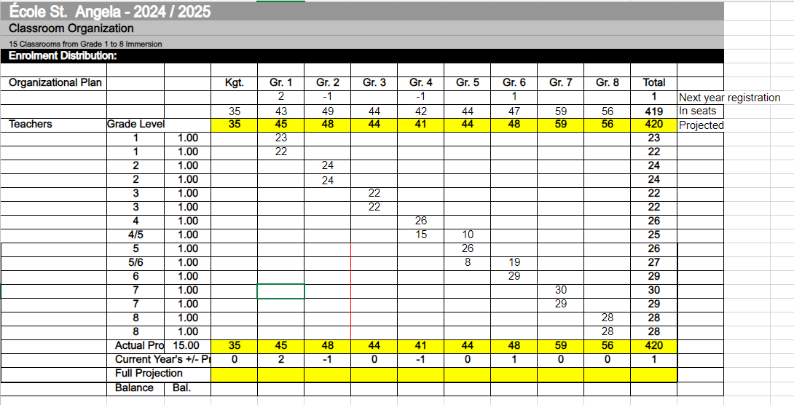
- Predicted drop from 440 students to 420 students.
- Currently, we have 61 grade 8 leaving us, and on have 26 kindergarten registered for 2024-25 at this time.
- Result: Drop from 18 classrooms (Grade K-8) to 17 classrooms.
- Result: Removal of 2 portables during the summer.
- Staffing Ratios:
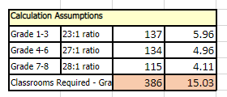
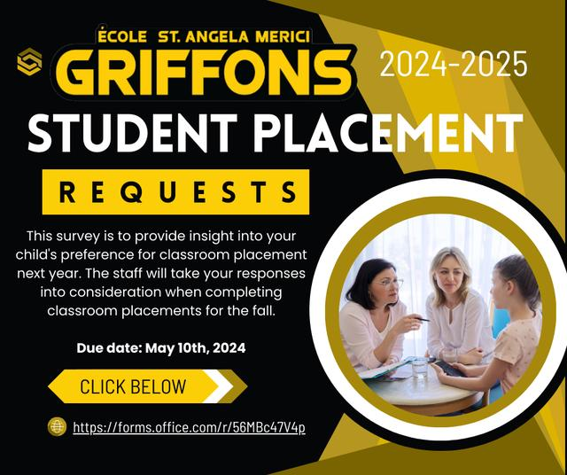
https://forms.office.com/r/56MBc47V4p
Currently we have 55 requests from parents/guardians
Angel Fund Committee - Led by Merelda
Nothing to report this month

Old Business
1) Spring Dance Planning – Led by Breigh M.
- Signup Genius has been posted for parent volunteers
- Save the Date with dance details has been posted
- Mme. Wiseman has met with the Griffon Gang student committee to come up with a decorating plan and inventory of decorations
Details: May 10,2024 6:00-8:00pm family grades K-4, 8:00-10:00pm senior grades 5-8
Entrance Fees: $2 per person - $5 per family
Canteen: Chips/pop/water/candy cups- $2.00
50/50 raffle will be held during the family dance

Motion to Provide $100 for the Purchase of Additional Decorations/lights: Fawn
Seconded: Breigh
Motion Passed

2) Playground Committee (Grant Application) Update – Led by Merelda
Nothing to Report this Month

New Business
1) Playground Fundraiser Discussion/Planning – Led by Merelda/Céline
- Will be having an Online 50/50 raffle– May 21st to June 3,2024
- Céline and Tracy C. will work with SLGA and Rafflebox on set up with raffle
- Once license has been obtained by SLGA, advertising will be sent out to the school community

Motion to Adjourn Meeting: Krista

Seconded: Daniela
Motion passed.

Our next meeting is June 3,2024 at 6:30pm. The AGM will be held that evening as well. Merci!

