École St. Angela Merici
Catholic Community School Council Meeting
Thursday October 17, 2024 at 6:30pm
Richard Turchenek Resource Centre and MS Teams Online

ATTENDANCE: Merelda Potter, Meagan Ireland, Derek Fischer, Hayley Fischer, Daniella Glover, Amanda Garrioch, Daniel Lizee, Bryan Dubord, Mike Orosz

ONLINE: Jenna Peters

Welcome & Prayer: Led by Merelda Potter

Read and Review Agenda: Led by Merelda Potter

Motion to Approve Agenda: Amanda Garrioch
Seconded: Mike Orosz
Motion passed.

Chair’s Report and Correspondence – Led by Merelda Potter
- $2000 provided to the school for busses for excursions
- Nov 26th meeting will be about the playground. We have invited city officials and RCSD representatives. Some help has been offered depending on the election results.

Angel Fund Committee - Led by Merelda Potter
- Cheque being issued for $500 to the school for food to be provided to students when needed. Food is stored in Daniel’s office and students can come and get it when needed. We provide fruit as much as possible.

Treasurer’s Report – Led by Amanda Garrioch
Bank Account Balances as of Oct 17, 2024:
Playground $19516.27
General/Operating - $12623.65

- Water Bottle currently at $4544
- Purchase of bottles were under $1100
- Currently Net Profit of $3444
- 173 children have participated to date
- Still one more week to go and tomorrow - today’s money is not yet counted.
- Received a cheque from SLGA (last year) from the 50/50 - transferring into the playground account as per previous motion
- $150 per classroom for Classroom Enhancements - $2400 cheque total

Motion to Accept Treasurers Report: Daniella Glover
Seconded: Bryan Dubord
Motion passed.

Administration’s Report – Led by Daniel Lizee

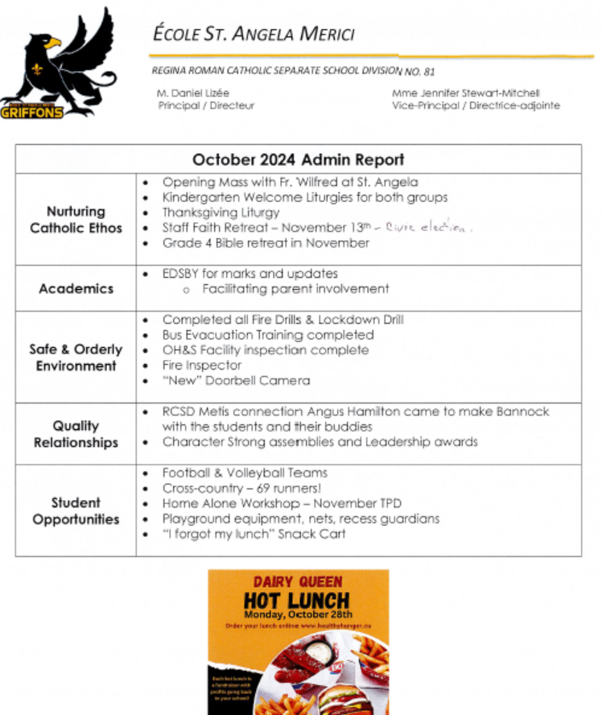

Nov 13th was chosen because of the Civic Election being held in the building on that day therefore we have planned that there will be no students in the building to ensure safety of students and staff.

Old Business
- Our School Survey Data Review - Daniel Lizee

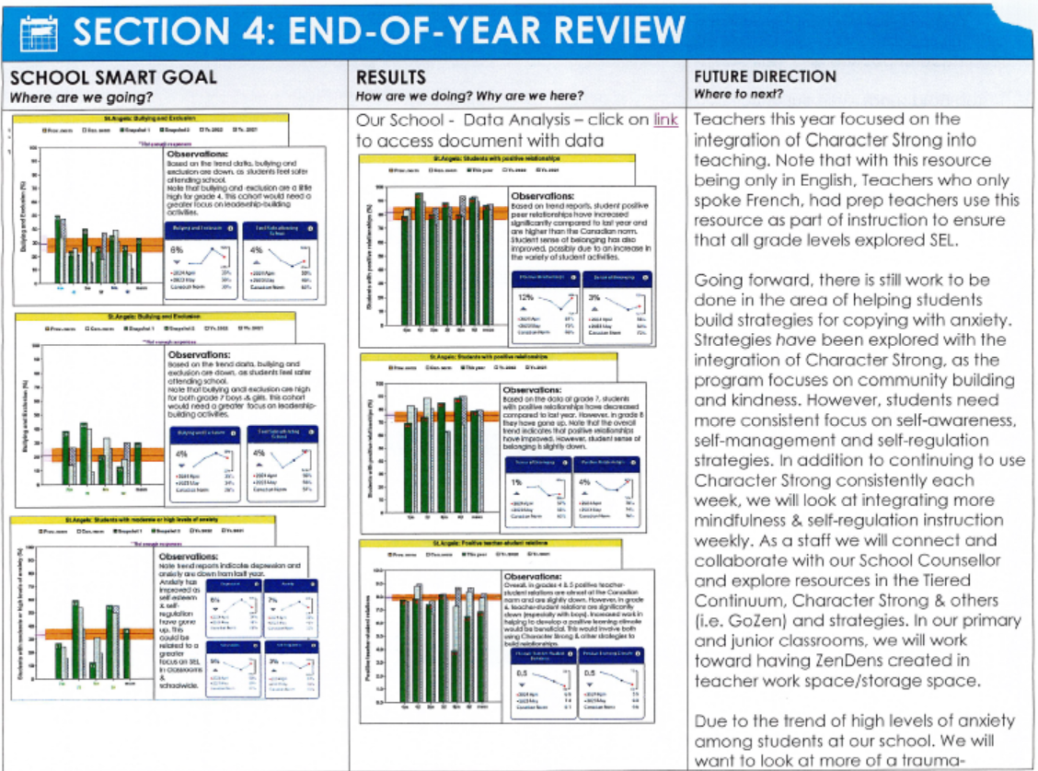

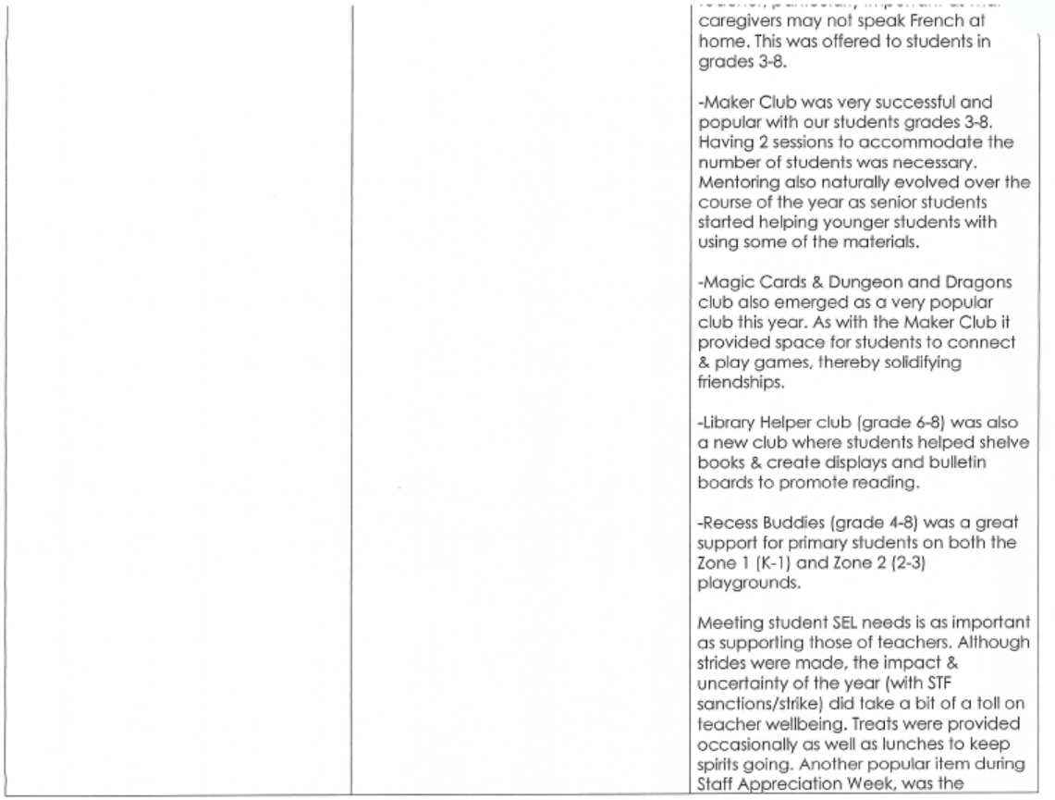

New Business
- Language change from Directors to Members-At-Large
  - Bryan Dubord & Mike Orosz - Members-At-Large Playground
  - Rhonda Nye - Members-At-Large Mabel Labels
  - Hayley Fischer & Derek Fischer - Members-At-Large Social Media
  - Andrea Birchard - Members-At-Large Auction
  - Jenna Peters - Member-At-Large Hot Lunch
- Change Bottle Update
  - Week 1 Assembly tomorrow for Early Bird Prizes
    - 100 kids to throw pies at teachers
    - Mme Fischer will eat a maple bug
    - Change Bottle money is going to the general account for:
      - Angel fund
      - Busses for classrooms
      - Classroom Enhancements
      - Other school initiatives
      - Keeps our base money stocked then extra will go to the playground
- Halloween Dance
  - Mme Wiseman and Breigh McDavid have everything planned.
  - 7 volunteer spots are still open - deadline is Oct 21st for volunteers. If we do not have enough volunteers by that date then we will cancel the dance. This is for safety.
  - ONLY students who attend St Angela can be in attendance. Older kids must be signed in and out.
  - Mme Wiseman requested $100 for prizes - motion passed previously
  - Dance does not lose money but it breaks even
  - 50/50 will run and a draw will be made at 7:15pm.
  - RCSD Grant will be spent on the Halloween Dance if it comes - Daniel will let the executive know when and if the money arrives.
- Hot Lunch
  - All planned and confirmed. Orders can be placed for the entire year.
  - Approximately 200 orders have already been placed.
  - Portion of sales comes back to the CSCC.
- Playground Committee
  - Budget has been reviewed and some playground companies have been contacted to start looking at the cost and what different types of structures can be built.
  - Twin Lakes Association is unable to help out with the playground in any capacity at this moment.
  - Review the letter that requests money to include more businesses at a lower donation amount and how those donations are managed. Include details on how to recognize the businesses that do donate - gratitude wall/signage/naming rights/donor appreciation day/etc.
  - Cassandra with Park and Play has provided us with a list of grants in addition to the list that Kenny provided from the past. Shannon also has provided us with a list of grants.
  - Double checking on cost and availability of structures with the companies.
  - Potentially running a 50/50 for fundraising after Christmas. Online Auction goes towards the playground funding. Use RaffleBox to run the 50/50, run a leaderboard and then have prizes for class totals.
  - Playground is owned by RCSD (Front of the School) and/or City of Regina (Back of the School). Potentially taking away the front playground and only having the side and back playground, which would then make fundraising easier to continually change and update our playgrounds. Three playgrounds is very difficult to manage for fundraising and a supervision nightmare for scheduling.
  - Once we have an advertisement and final details then we can push out to the local community associations to post on their facebook pages etc.
- Social Media Update
  - Posting as much as possible and at high traffic times. Posting stories to help increase traffic. Things are scheduled to be posted! Followers have not increased much but we are still pushing it to the public.
  - Holding off on Instagram because Facebook is not a separate account. We are still looking at separating Facebook from Merelda’s account.
- Tax Filing Requirements
  - There is a requirement to file a T2 tax return from the Government, but there is no consequence to not filing therefore the executive has been advised to not file a tax return
- November 26th Meeting
  - Start with the Playground - City officials and RCSD Representatives
  - Finish with a regular meeting to discuss the following
    - Fundraiser Update
    - Grant Money
    - Oranges & Candy Canes
    - 50/50 Playground Fundraiser January
    - Teacher Christmas Treats

Motion to Adjourn Meeting at 8:30pm: Bryan Dubord
Seconded: Hayley Fischer
Motion passed

Our next meeting is November 26th @ 6pm. It will be focused on the playground. City officials and RCSD representatives have been invited. Hope to see you there! Immediately after the playground meeting will be our regular executive meeting.

