École St. Angela Merici
Catholic Community School Council Meeting
Wednesday, October 11,2023
Richard Turchenek Resource Centre and MS Teams Online

Welcome: Led by Merelda

Read and Review Agenda: Led by Merelda

Motion to Approve Agenda: Krista
Seconded: Daniela
Motion passed.

Motion to Approve Past Meeting Minutes: Rhonda, Daniela
Motion passed.

Chair’s Report and Correspondence – Led by Merelda
Mostly organizing the fundraisers and the dance so will discuss those later in the agenda.
Lined up the Pats mascot to help handout popcorn which was great. Maybe again for the 20th. The players would have come but they are playing on Fridays. Considered UofR athletes but they were out of town. Anyone know the Regina Red Sox? Riders want to be paid for, so won’t pursue them. Safety Bob? Can ask Resource Officer. Co-op bear? Mme Wiseman/Metz has a connection to Rider Cheerleaders - Mme Wiseman will check on that, will try that one first.

Treasurer’s Report – Led by Krista
- Review of Treasurer’s spreadsheets
Account Balances at September 30,2023:
Playground - $17,133.40
General - $6301.29 (after $3,300.00 just paid out for classroom enhancements)

Motion to Accept Treasurers Report: Fawn
Seconded: Rhonda
Motion passed.

Administration’s Report – Led by Daniel L. and Jennifer S.M.

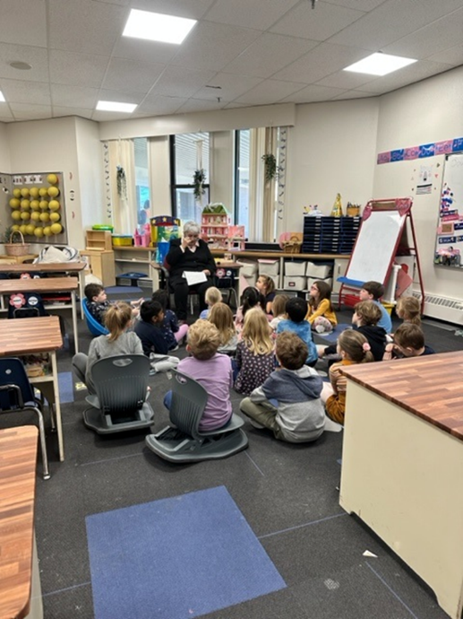
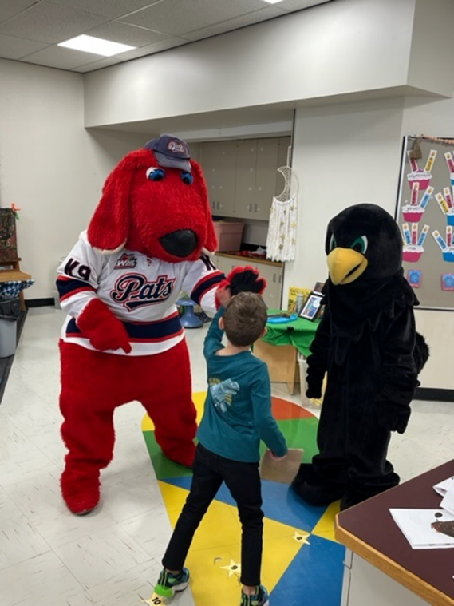
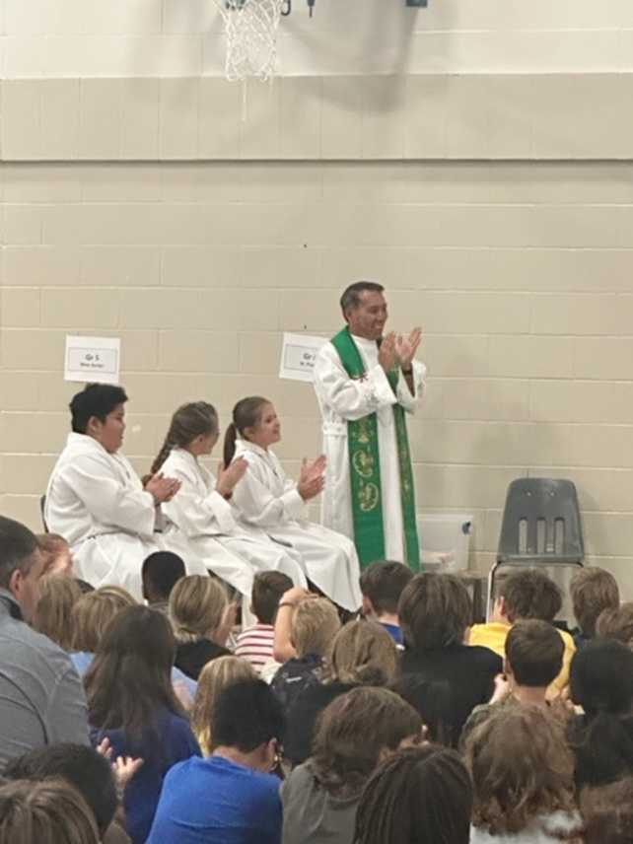
PRINCIPAL REPORT October 2023
We are fortunate to have Elder Hazel join us on Mondays to help with the Character Strong & Seven Sacred Teachings.
Opening Mass with Fr. Wifred & Holy Family Parish

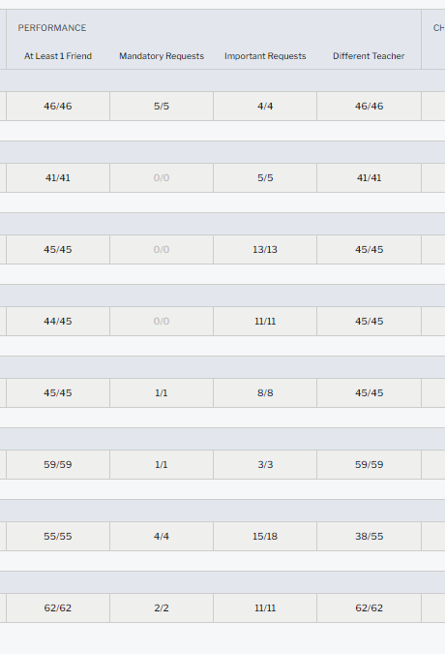

Terry Fox was a great success! $1300 for Cancer Research.
Classroom placements were considered to assist with Our School Survey Data results.

***Looking for feedback on Edge School Photographers or other suggestions. Email Daniel.

Angel Fund Committee - Led by Merelda
Cold weather season coming up so will need a stash of toques and mittens, ski pants. Will use from lost and found. Will take donations.
May be helpful to have money for snacks. Not a large need, but on occasion student forget and are hungry so cannot concentrate. Apple sauce, granola bars, fruit.

Motion to provide $250 from Angel Fund for snacks: Daniela
Seconded: Rhonda
Motion passed.

Old Business
1) Halloween Dance Update – Led by Merelda
Breigh already booked the DJ.
Merelda launched the Sign-Up Genius today. Its half full already! It’s on Facebook, Edsby.

*Mme Metz and Mme Wiseman have set up a student leadership committee. Had 26 applications and are keeping them all. Have not decided on a name yet. Halloween Dance is their first event. Explained to them this is about more than making posters, you want to encourage and hype it up. They really took it seriously and are thrilled about it. Mme Wiseman invites us to bring to her any events or activities that we could use student leaders’ involvement as they are looking for leadership opportunities. *
CSCC has provided $150 dollars for the student leadership committee for some new decorations. Smaller items since we still have the inflatables etc. Photo booth. Posters for the canteen. Will check SeaCan.
Merelda will get canteen purchase list for Celine. Will buy same as last year, except no more chocolate bars. Changed prices to $2.
Door prizes – Need 6 X $20 gift cards – Krista will purchase.
Celine will apply for lottery license when she’s back.
Have 2 cases and 8 packs of popcorn left. Will probably use it all next Friday. Merelda/Daniela will pick up more popcorn.

2) Upcoming Fundraisers – Led by Merelda
a) Lucky Loonies
Made just over $900 this week. Going well!
Big class prize – head of K9 Police Unit will do presentation. Paperwork required to have dog in school. Fun experience. The week after the last Friday.
Still trying to find a group for the 20th.
Will have to see how much money we make after the popcorn expenses. If we don’t make a ton of money, then we will charge $2 next time. Either way, kids are enjoying it.

b) Farm Fresh Vegetables
Closes Oct 20. We reached the minimum purchase threshold. Close to $1200 so far. 1/3 is going straight to the foodbank, just like last year. Food bank appreciates our Nov delivery date. We will need to send out reminder closer to pick up date.

c) FundScrip Gift Cards - Daniela
Coming up November 15-29. Think we can make the form fillable.

New Business
1) Annual Student Survey – Led by Daniel and Jennifer
This survey is mandated by SK government. We will be doing it in Oct/Nov.
What do we do with the data? One example is – we learned anxiety was a major theme on our survey – so with knowing this, and knowing how important having a friendly face in your class and that can help with anxiety, we took requests for classroom placements from parents and students and put it into a computer program. Every kid in the school got at least 1 of their top 3 picks! All mandatory requests were met, while balancing the other needed considerations. The program indicated which students may need extra attention. Can also see who did not have any requests for them so we can be sure to support those students. Building a sense of community. Will continue to grow how the survey helps us. Need to look at big picture, overall data as there are some contradictions. Not all students take the survey seriously and do not answer honestly. So we take it seriously, but with a grain of salt. The program we use is very helpful.

Motion to Adjourn Meeting: Krista
Seconded: Daniela
Motion passed.

Our next meeting is: Monday, November 20, 2023 at 6:30pm. We can’t wait to see you there!

